*SWE40001, Software Engineering Project, Semester 1, 5/04/2018*

Smart-glass based remote guidance system

MANUAL TESTING

Group 21  
 Lyndon Prado - 9740783  
 Tingcong Jimmy Li - 100017000  
 Keagan Foster - 101609822  
 Ayub Khan - 100667654  
 Dineth Gunawardena - 100862158  
 Kosala Edirisinghe - 101265981  
 Krishna Adhikari - 4953193  
 Liam Pan -101106174  
 Migara Gunarathne - 101002269  
 Shenal Nirushka – 10105499

## 

**Table 1. Document Change Control**

|  |  |  |  |
| --- | --- | --- | --- |
| **Version** | **Date** | **Authors** | **Summary of Changes** |
| 1.0 | 04/10/2018 | Dineth Gunawardena | Initial draft created with Overview, Procedure and Test Case Template |
| 1.1 | 08/10/2018 | Ayub Khan | Updated Test Scenario and Test Cases |
| 1.2 | 14/10/2018 | Ayub Khan, Shenal Nirushka | Updated Test Cases |
| 1.3 | 14/10/2018 | Dineth Gunawardena, Ayub Khan | Updated Results table with Manual Testing results |

## 

## Overview

The process of manually executing test cases without automation tools is called manual testing. A tester acts as an end user testing the features of the system, with a test plan document that thoroughly describes a detailed testing approach to the system's features. If a difference is found between the actual and expected result, it is treated as a defect, that must be fixed.

## Procedure

1. Requirement Analysis

2. Test Plan Creation

3. Test Case Creation

4. Test Case Execution

5. Defect Logging

6. Defect Fix & Re-Verification

An application must be manually tested before automation testing can be used. Any type of software testing can be executed both manually and by automation. Manual testing needs human intervention while automation testing does not.

## Test Case Template

|  |  |
| --- | --- |
| **Test Scenario ID** | **Test Scenario Description** |
| 1 | Check Web Server functionality, efficiency and response |
| 2 | Check hand gesture recognition and transmission |
| 3 | Check tracing/drawing, finger tracking and transmission |

## Test Cases

|  |  |  |  |  |
| --- | --- | --- | --- | --- |
| **Test Case ID** | **Test Case Description** | **Test Steps** | **Pre**  **Conditions** | **Expected Result** |
| 1.1 | Connect two devices to the web server | 1. Turn on second device 2. open browser 3. scan QR code and connect to the web server | Connection to wifi established | Connection between both devices is established |
| 1.2 | Connect three devices to the web server, 2 as non admin devices and one as admin | 1. Turn on third device 2. open browser 3. scan QR code and connect non admin devices to the web server 4. connect admin device using URL | Connection to wifi established | Connection is established between the two devices and the server. Connection between both devices is established  The device connected as admin will display the calibration screen |
| 1.3 | Connect three devices to the web server but all three as non-admin devices | 1. Turn on third device 2. open browser 3. scan QR code and connect non admin devices to the web server , | Connection to wifi  established | The third device will not be connected and will not stream .  The third device will display a black screen. |
| 2.1 | Calibrate system to detect the correct color | 1. Press the calibration for hand button to take a screenshot from the admin page 2. Click on the correct part of the image to calibrate the color | Admin and 2 non admin devices are connected to the web server | System will be calibrated appropriately to detect the correct  color |
| 2.2 | Check Hand Gesture Recognition and transmission | Instructor must place hands in view of the smart glass camera for hand recognition | Connection between the 2 devices has been established | System detects hand gesture, server extracts hands and overlays them with operator’s video stream. |
| 2.3 | Calibrate the system to detect the incorrect color | 1. Press the calibration for hand button to take a screenshot from the admin page 2. Click on the incorrect part of the image to calibrate the color | Admin and 2 non admin devices are connected to the web server | The system will detect and overlay objects of the incorrect color |
| 3.1 | Calibrate system to detect the correct color for finger point | 1. Press the calibration for pointer button to take a screenshot from the admin page 2. Click on the correct part of the image to calibrate the color | Admin and 2 non admin devices are connected to the web server | System will be calibrated appropriately to detect the correct  color |
| 3.2 | Check pointer recognition and center point detection | 1. The instructor presses the T button to start tracing | Pointer color is correctly calibrated | System traces along the path of the pointer correctly. |
| 3.3 | Check if user can end tracing process | 1. The Instructor presses the T button to end the tracing | The system is currently tracing | System ends tracing process successfully but the trace still remains on the screen |
| 3.4 | Check if operator can view tracing | Operator must be able to view trace done by instructor | Pointer color is correctly calibrated | System overlays trace over operator video feed |
| 3.5 | Calibrate system to detect incorrect color for finger point | 1. Press the calibration for pointer button to take a screenshot from the admin page   Select incorrect color for finger point color calibration | Admin and 2 non admin devices are connected to the web server | The user will be unable to trace |

## 

## Results

|  |  |  |
| --- | --- | --- |
| **Test Case ID** | **Actual Result** | **Comments** |
| **1.1** | **System successfully connects both devices (Refer to Figure 1)** | **__** |
| **1.2** | **System successfully connects 3 users 2 non admins and one admin (Refer to Figure 3)** |  |
| **1.3** | **System connects 2 user but the third user remains unconnected (Refer to Figure 5)** | **The system cannot connect 3 non-admin users as it is hardcoded into it.** |
| **2.1** | **System successfully calibrated (Refer to Figure 7)** |  |
| **2.2** | **System detects hand gestures (Refer to Figure 7)** |  |
| **2.3** | **System detects objects matching with incorrect color (Refer to Figure 10)** |  |
| **3.1** | **Finger point color Calibration successful (Refer to Figure 6)** |  |
| **3.2** | **System successfully detects finger point (Refer to Figure 9)** |  |
| **3.3** | **System successfully draws trace along point path and ends trace process on button click (Refer to Figure 11)** |  |
| **3.4** | **Operator can successfully view tracing (Refer to Figure 8)** |  |
| **3.5** | **As expected,The user was unable to trace (Refer to Figure 12)** |  |

*Figure 1*

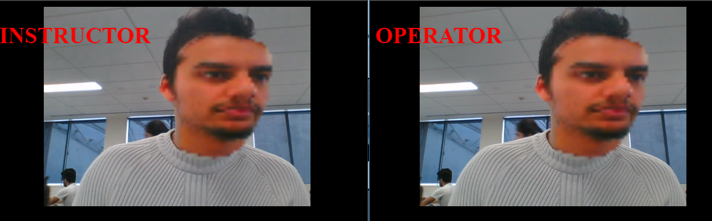

*Figure 2*

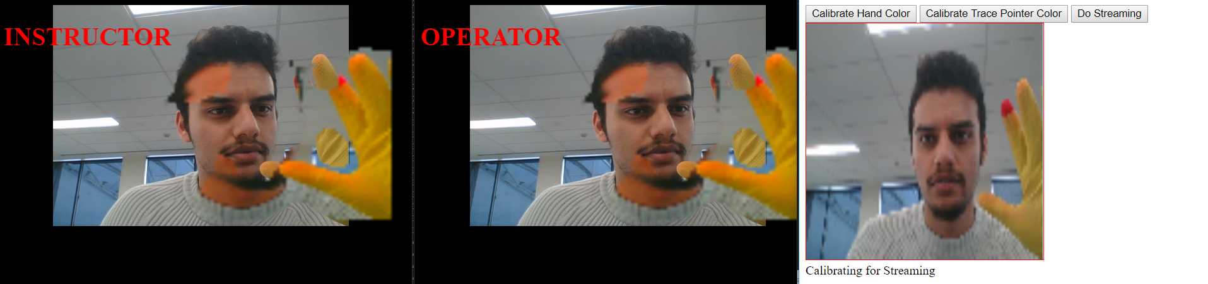

*Figure 3*

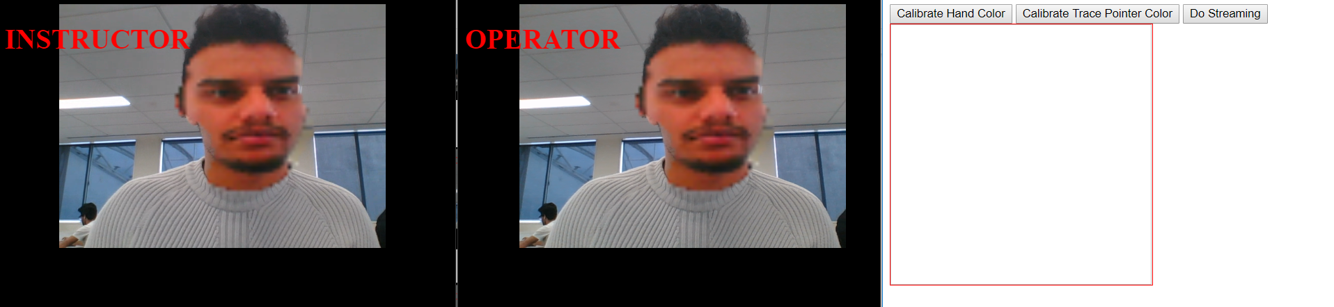

*Figure 4*

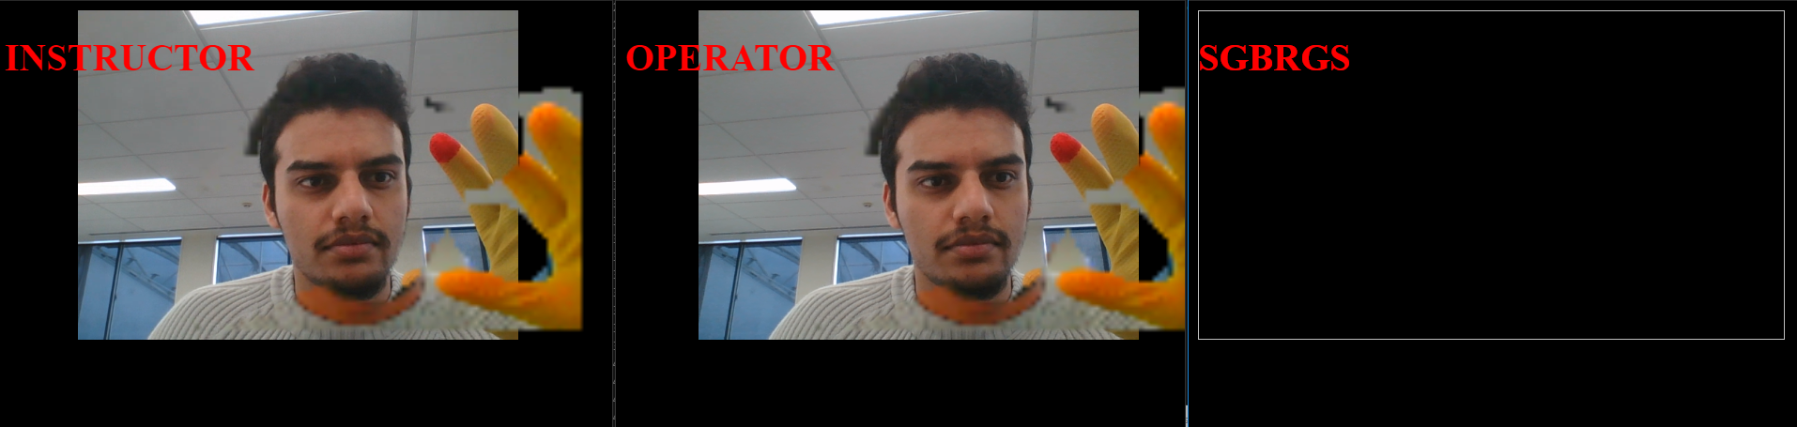

*Figure 5*

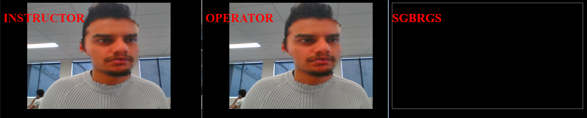

*Figure 6*

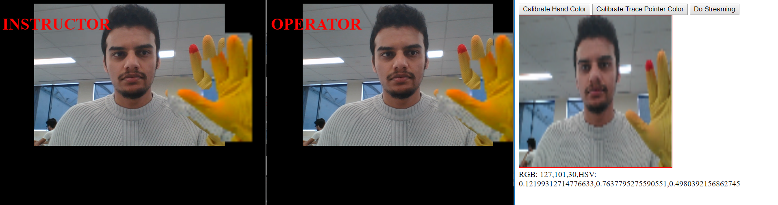

*Figure 7*

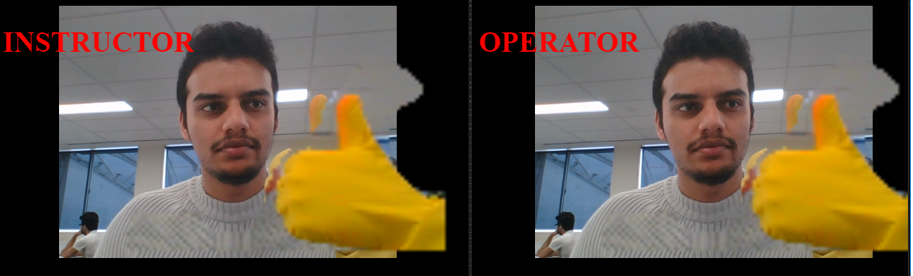

*Figure 8*

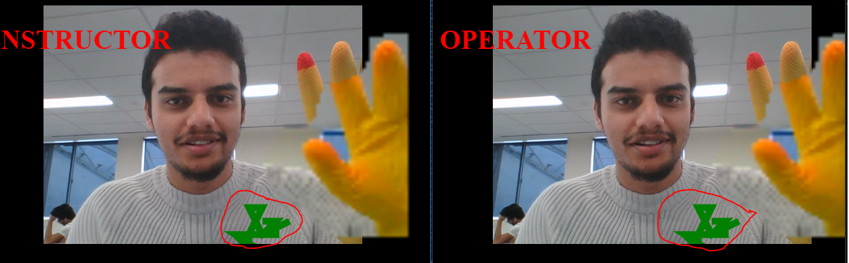

*Figure 9*

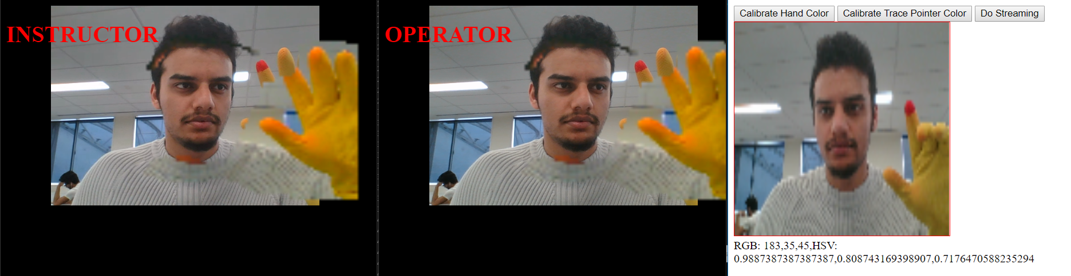

*Figure 10*

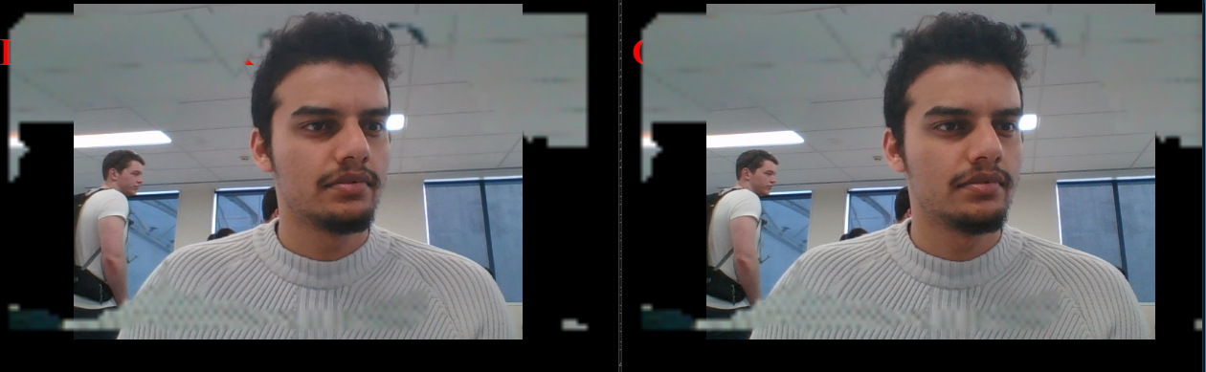

*Figure 11*

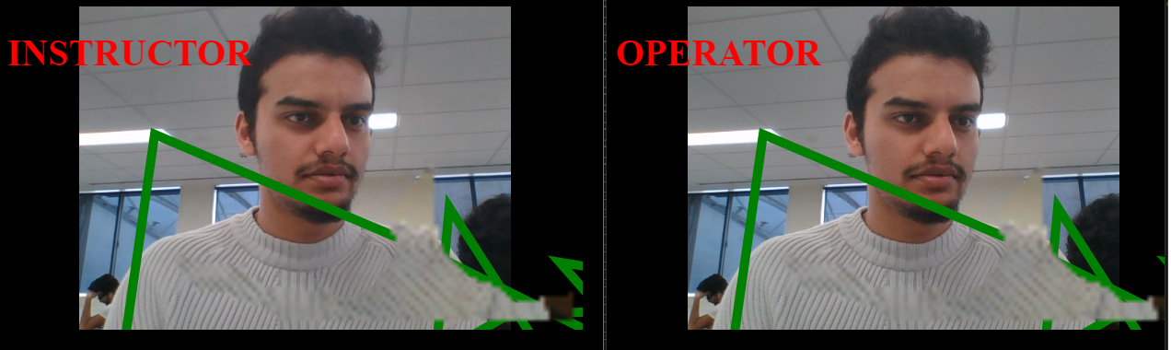

*Figure 12*

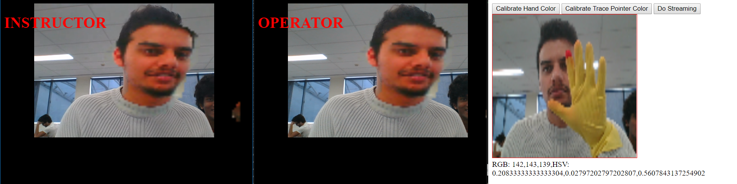

## Defect Logging

Since the testing was done during the final stages of the project no anomalies were found .